Faculty Workload Management –FWM Quick Resource Guide for MSCF Faculty

Table of Contents

Introduction 2
Accessing the FWM Application 2
Workload Details 3
Class Schedule 3
Course Details 5
Non-Instructional Assignment Information 6
Additional Documentation 7
Need Help 7

Introduction
The Faculty Workload Management (FWM)
application provides an integrated and automated process to transmit faculty assignment data from Academic and Student Affairs to Human Resources. This guide may be used to assist you in navigating through the FWM application to review details of your faculty workload.

Accessing the FWM Application
- Browser - You must use either Firefox or Chrome to log in to the FWM application.
- You will log in to the FWM application by going to the following link: https://eservices.minnstate.edu/fwm/secure/main/ your Star ID and Password.
- If you have difficulty logging in, or need help with your Star ID, contact the ITS Service Desk at https://servicedesk.mnscu.edu/ or call 877-GO-MNSCU (877-466-6728)

Workload Details

The Workload Details page provides you with an online view of the details about your work assignments at all MnSCU institutions. The page displays class schedule, base salary and salary overload by academic year for any year after 1999 that you have courses at a MnSCU institution. Beginning in Fiscal Year 2017, instructional and non-instructional details for FY17 and beyond will display, including class schedule, Base Salary, courses for any term where there is workload, and any non-instructional assignments, for instance assignments that are not part of the course term schedule. Only terms that the instructor has courses or non-instructional assignments will display on the screen.

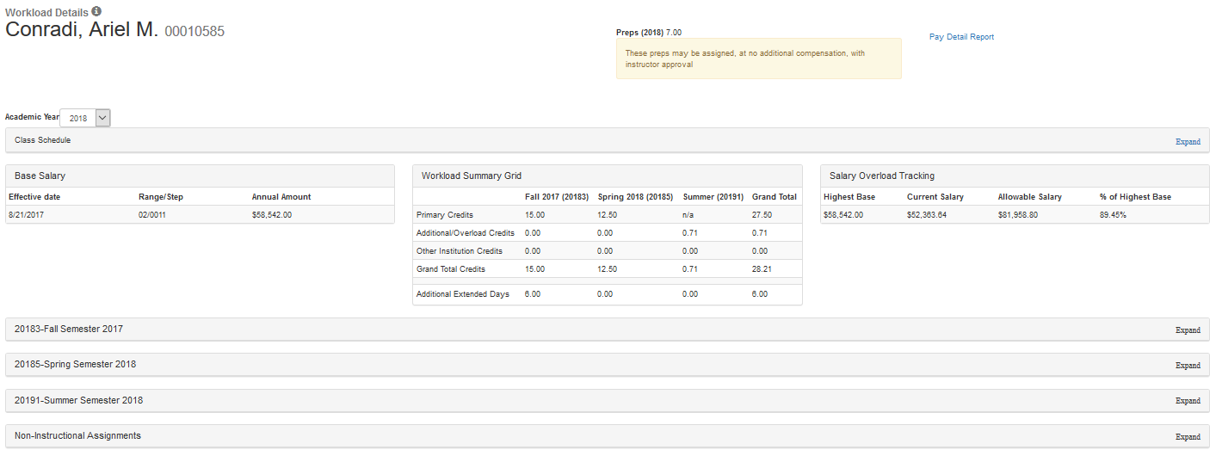
Change Academic Year
View Courses by Term
View Class Schedule

Class Schedule
The class/course schedule displays a weekly (Monday to Sunday) grid from information located in the master course schedule. The weekly calendar grid begins at 6:00 am through 11:00 pm for each day in the grid, one block for each hour. If a course is offered for a time that is not within the 6:00 am through 11:00 pm period or it is an online or arranged meeting time course, it will be displayed below the calendar. Offered courses from all MnSCU institutions will display in the calendar or listing below the calendar.

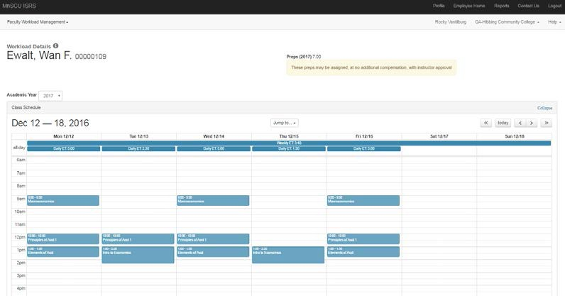

Base Salary, Credits to Pay, and Percent of Full-Time Work
- Base Salary – Displays a base salary for faculty work for the academic year or there may be more than one base salary in effect over the course of an academic year.
- Credits to Pay – Displays for academic year and summer credits, non-instructional, and credits at other institutions.
- Salary Overload Tracking - Salary overload tracking includes the following information:
  - Highest base salary across all MSCF jobs at all MnSCU institutions for the selected academic year.
  - Allowable salary – highest base times 1.4.
  - Current salary – sum of all qualifying assignment dollars across all MnSCU institutions for the selected academic year
  - % of highest base (cannot exceed 140%) – Current salary / Highest base
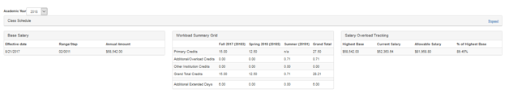

Course Listing and Selection
Click on any course listing to see additional details about the course and workload details.

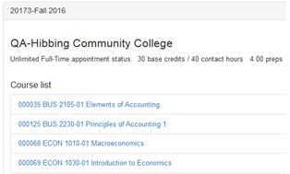

Course Details
This section includes the details of the course, plus the faculty member’s assigned load (Pay Info), and a hiring reason if one has been entered. The workload status indicates the status of the payment for the course:
- Pending (course has been assigned to the faculty member in the course term schedule, but not yet approved by the Dean for payment);
- Approved (course has been approved for payment by the Dean);
- Processed (payment for the course has been processed by HR).
If a workload record is changed after it has been processed, you will receive an email to let you know there has been a change in your workload record that you can review in FWM with a link to the application.
Additional detailed information can be found in the Faculty FWM User Guide.
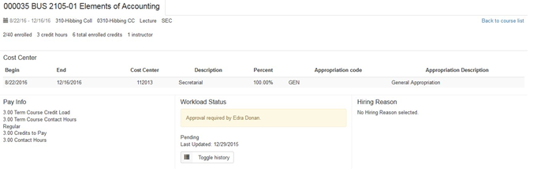

Non-Instructional Assignment Information
The Non-Instructional assignment section will display assignments for which a faculty member must be paid, but the details of the assignment are not sourced from the Term Course Schedule. Some examples are Counseling, Librarian, Chairperson, honorarium, coaching, etc. Note: Leaves of absence are not included in non-instructional assignments. If there are assignment letters or other documents attached to the Non-Instructional assignment, you will see a pdf attached under the Assignment Letters section. You may open and review any attached pdf documents.
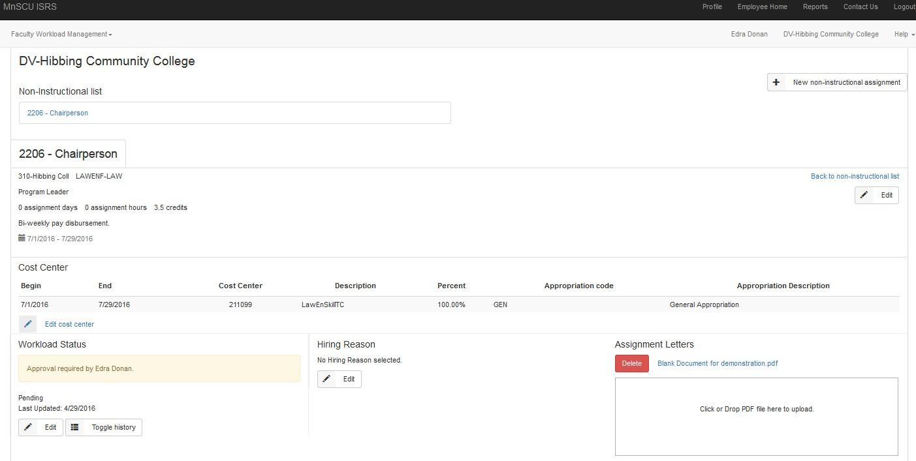

FWM Additional Information and Resources
NOTE: All information displayed in the Faculty Workload Management System is ultimately dependent on the accuracy of data entered into the system. Accordingly, data entry errors may occur from time to time. The Employer reserves the right to correct any data errors in the FWM system and, if necessary, to correct any payroll errors that may result.
Some of the information displayed on Individual Faculty Workload pages may not be relevant to your employment situation. If you have questions, please consult your collective bargaining agreement, or contact the HR office at the college or university where you are employed.
After reviewing your workload details, you may direct questions to the following:
• Log-in/Access Issues: For assistance with accessing the FWM application, contact the ITS Service Desk at http://servicedesk.minnstate.edu/CherwellPortal/MNSO or call 877-GO-MNSCU (877-466-6728)

FWM Load, Schedule, and Credits to Pay: Faculty should contact their supervisor/Dean with questions about workload details.
Base Salary, Rate of Pay, etc: Faculty should contact Human Resources with questions about pay.
Pay Details – Details about the amount you are scheduled to be paid and the payment dates can be found on the Pay Details Report which is available in the Time and Leave Reporting Application. Here is a link to the Pay Details user guide.

Additional Documentation
Faculty Workload Management User Guide

Need Help
If you need additional assistance, please contact the ITS Service Desk at http://servicedesk.minnstate.edu/CherwellPortal/MNSO

