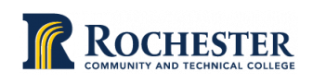

**Rochester Community and Technical College Voter Engagement Plan**

Developed by: Samantha Herrick

Approved by RCTC Student Government Executive team on July 30th, 2024

|  |
| --- |
| **Executive Summary**: |

This nonpartisan democratic engagement action plan was developed by Rochester Community and Technical College in Rochester Minnesota for the 2024/2025 academic year. The purpose of this action plan is to increase nonpartisan democratic engagement and student voter registration, education, and turnout in the 2024 election. The goals for Rochester Community and Technical College for the 2024 election are to spread awareness about the importance of voting, how to/where to/when to vote, increase voter turnout for RCTC students, and empower RCTC students to advocate for their rights and others both on and off campus.

|  |
| --- |
| **Leadership:** |

Our leadership team includes the following campus groups, departments, and individuals:

* Samantha Herrick- Student Life Coordinator
* Lexi Fernandez- Student Engagement Specialist
* RCTC Student Government
* Other departments as desired/needed

|  |
| --- |
| **Commitment:** |

Rochester Community and Technical College mission is to “empowers students to thrive in an ever-changing, diverse society by providing access to exceptional education”. By creating diverse programming that engages students across campus our hope is that students will see the impact their voice can have and will thus increase their commitment to advocate for themselves and others through the power of voting.

The Rochester Community and Technical College community is committed to providing students with nonpartisan democratic engagement through Student Life programming, guest speakers, campus wide emails, and readily available voter information located on the [RCTC Student Life](https://www.rctc.edu/studentlife/) home page.

|  |
| --- |
| Landscape: |

Rochester Community and Technica College is a two-year public community college located in southern Minnesota that was founded in 1915.

Our campus demographic is as follows:

Rochester Community and Technical College serves 5,195 students with 63% of students being part time and only 37% of students being full time.

Rochester Community and Technical college is a diverse campus that serves students throughput the greater southern Minnesota region and beyond:

* Asian – 5%
* Hispanic – 8%
* American Indian/Alaska Native – 0%
* Nonresident Alien – 1%
* Native Hawaiian/Pacific Islander – 0%
* Not Reported/Unknown – 3%
* Black or African American – 14%
* Two or More Races – 4%
* Caucasian – 65%

Rochester Community and Technical College has authorized the National Study of Learning, Voting, and Engagement (NSLVE) and has received campus voting data for the 2022 election. Our NSLVE authorization runs through 2033. This data helps the RCTC community to better understand their voter turnout and where increased efforts can be made.

**Voting, Registration and Rates:**

**By Race/Ethnicity:**

The arrow to the right of each bar represents the relevant national averages.

**By Age Group:**

**By Gender:**

**By Enrollment Status**

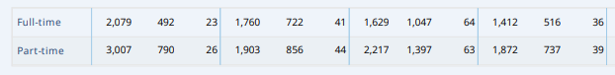

**Voting Method:**

Outer ring represents national levels and the inner ring shows RCTC voter methods.

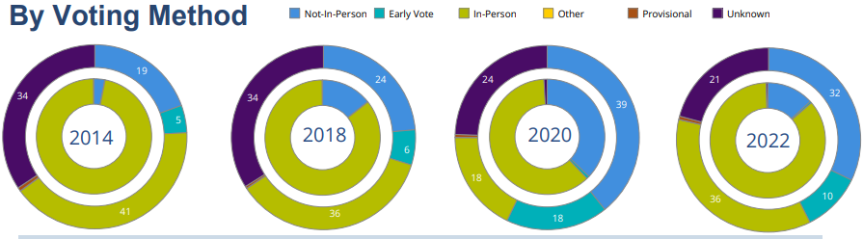

Rochester Community and Technical College participated in the following initiatives to support the development and implementation of our nonpartisan democratic engagement efforts on campus: National Voter Registration Day (2024); National Voter Education Week (2024).

|  |
| --- |
| **Goals:** |

Our institution’s nonpartisan democratic engagement goals are to:

* Increase student voter turnout rate to 41% in 2024 and 45% in 2026.
* Increase student voter registration rate to 75% in 2024 and 80% in 2026.
* Add voter registration materials to new and transfer student orientation events for fall 2025.
* Hold a minimum of two voter engagement events per academic year.

|  |
| --- |
| **Strategy:** |

Events:

In hopes of increasing voter turnout/registration Rochester Community and Technical college has held/will be holding the following events:

* Sept. 11th- Olmstead County Speaker: how to register, laws and regulations, etc. Trivia and swag give away!
* Sept. 17th – National Voter Registration Day: What Floats Your Vote: Root beer floats handed out by Student Government with information regarding voter registration. (Appendix A)
* Oct. 30th- Get Out ‘N Vote event: hosted by Student Government and Student Life.
* Ongoing voter registration tabling for both fall and spring semester (Appendix B)
* April 2nd – Student Government and Student Life will partner to host a Why Voting Matters event

Campus Wide Communication:

* A campus wide email solely devoted to voter information was sent on September 13th to all 5,195 RCTC students (Appendix C)
* A campus wide email solely devoted to the importance of voting will be sent on March 12th (Appendix D)

In addition, the [Student Life home page](https://www.rctc.edu/studentlife/) continues to share important links about voting.

Housing List:

Housing lists for all students with local addresses (i.e. Rochester addresses) were sent to the Olmsted County Election Office before each election. This year a housing list was sent on July 26th and October 15th

|  |
| --- |
| **Evaluation:** |

We will evaluate our action plan in the following ways:

* Rochester Community and Technical College will use the National, Study of Learning, Voting, and Engagement to evaluate the increase of student voting by comparing our campus voter turnout and voter registration rates to past elections to measure progress on increasing both.
* Student Life will track attendance at voter engagement events to determine which events are most successful and thus reaching a larger audience.
* At the end of the academic year Student Life hopes to create Mentee that allows students to provide input on how they feel about voting and what their takeaways are from the voter engagement programming they participated in throughout the year.

|  |
| --- |
| **Reporting:** |

Rochester Community and Technical College will share the Voter Engagement Action Plan on our Student Life page along with the NSLVE report. Student Affairs in particular will be notified of the report once completed but all faculty, staff and students will have access to the full report.

**Appendix A:**

Sticker used on the cups for Float Your Vote event

**Flier for Float Your Vote Event:**

**Appendix B:**

Flier used at tabling events throughout the fall/spring semester

**Appendix C:**

Fall registration emails sent Friday Sept. 13th, 2024

**Appendix D:**

**Subject: Why Your Vote Matters**

Dear RCTC Students,

I hope this message finds you well. Though we are not currently in the midst of an election season, I wanted to take a moment to remind you of the powerful role your vote plays in shaping the future of our communities and our country. Voting is more than just a civic duty—it's an opportunity to make your voice heard and to influence the decisions that affect our daily lives.

Here are a few reasons why your vote truly matters:

1. **It Determines the Future:** Elections have a direct impact on everything from local policies to national laws. Whether it's education, healthcare, infrastructure, or the economy, the candidates we choose will make decisions that affect us all. Your vote helps to steer the direction of these decisions.
2. **It Amplifies Your Voice:** In a democracy, every individual has the right to participate in shaping the government. Voting is one of the most powerful ways to express your opinion on the issues that matter most to you. When you vote, you're contributing to a collective voice that reflects the diversity of our society.
3. **It Holds Elected Officials Accountable:** Voting allows us to hold our leaders responsible for their actions and policies. If you're unhappy with how things are going, your vote is a tool to either support candidates who represent your values or change the leadership to better reflect your needs.
4. **It Strengthens Democracy:** The strength of our democracy relies on the participation of its citizens. When more people vote, the government more accurately represents the will of the people. By voting, you're helping ensure that democracy remains vibrant and inclusive.
5. **It Makes a Difference in Close Elections:** In many races, especially at the local level, elections are decided by just a handful of votes. Your vote could be the one that tips the balance, leading to changes in policies that directly affect your life and the lives of those around you.

To stay up to date on voting policies and upcoming elections in Minnesota as well as to access voter registration forms visit [The Secretary of State](https://www.sos.state.mn.us/elections-voting/) website.

Voting is not just a right—it's a responsibility we all share in making our voices heard.

Let’s make our vote count.

Best regards,