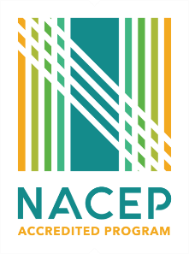

## **Concurrent Enrollment End of Semester Evaluation**

(E1 Standard: The college/university conducts end-of-term student course evaluations for each concurrent enrollment course to provide instructors with student feedback.)

**Directions:** With the liaison and CE teacher, review the student course evaluations and answer the questions below and return to Michele Altman at [michele.altman@rctc.edu](mailto:michele.altman@rctc.edu)

**CE Teacher Name** Click or tap here to enter text. **Concurrent Enrollment Course** Click or tap here to enter text.

**How effective was the course content in meeting learning objectives?**

Click or tap here to enter text.

**How do you incorporate student feedback into your teaching practices?**

Click or tap here to enter text.

**What are the most common themes in the student feedback you received?**

Click or tap here to enter text.

**How will you incorporate this student feedback into your teaching practices? Are there things you will change? Are there things you will continue based on the feedback?**

Click or tap here to enter text.

**Liaison feedback and summary of liaison and teacher discussion**

Click or tap here to enter text.

**Were there topics or materials you found particularly challenging to teach?**

Click or tap here to enter text.

**How would you rate your overall experience teaching this course?**

Click or tap here to enter text.